//Code

To find the transpose of a matrix

#include<stdio.h>

int main(){

int a[100][100],b[100][100],i,j,r,c;

printf("Enter the value of rows and columns");

scanf("%d %d",&r,&c);

for(i=0;i<r;i++)

for(j=0;j<c;j++)

scanf("%d",&a[i][j]);

for(i=0;i<c;i++)

for(j=0;j<r;j++)

b[i][j]=a[j][i];

printf("This is the original matrix\n");

for(i=0;i<r;i++)

{for(j=0;j<c;j++)

printf("%d \t",a[i][j]);

printf("\n");

}

printf("This is the transpose \n");

for(i=0;i<c;i++)

{for(j=0;j<r;j++)

printf("%d \t",b[i][j]);

printf("\n");

}

return 0;

}

Output:

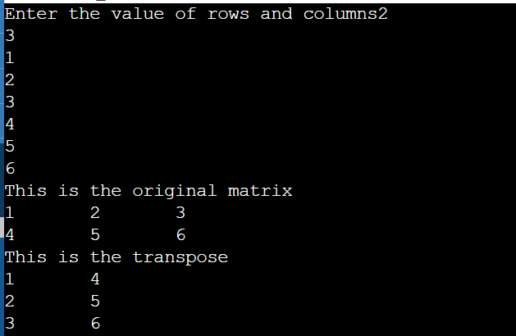

Conclusion:The code for factorial was successfully studied and implemented .